ABAP Z-Field Add Search Helper for simple setting

Data Source Table:ZTEST001 aim to :Show Dialog to choice data
Assignment Table:ZTEST002 aim to : Assign Data From ZTEST001

Table ZTEST001 Structure
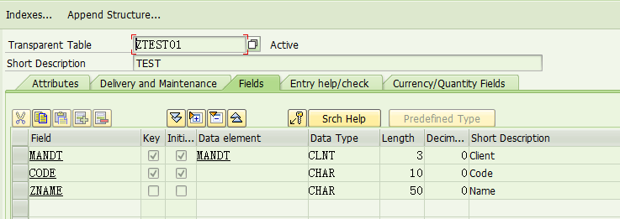
Data records
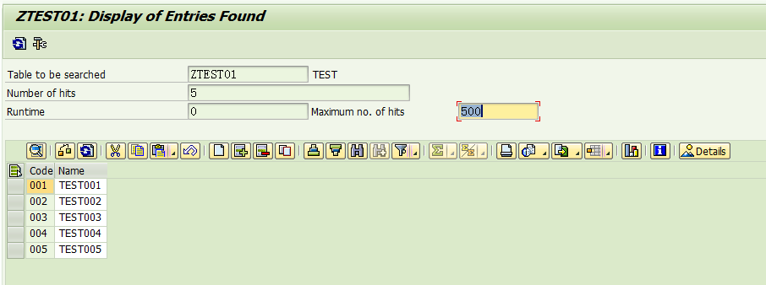

Table ZTEST002 Structure
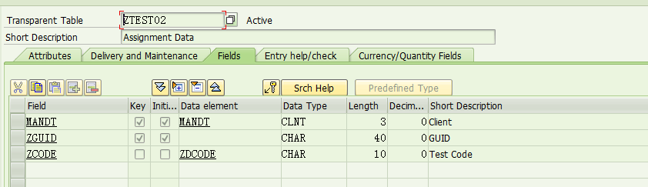
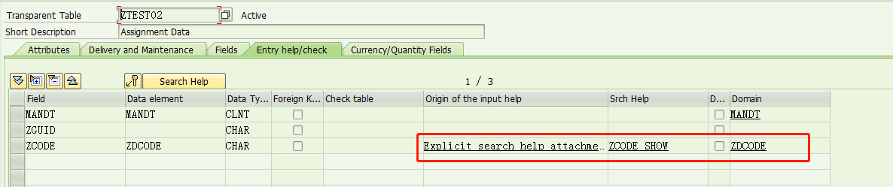
Data element:ZDCODE
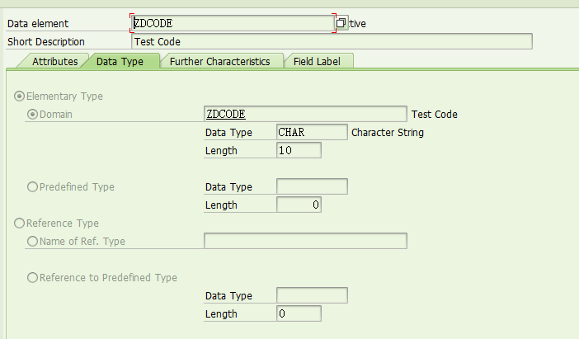
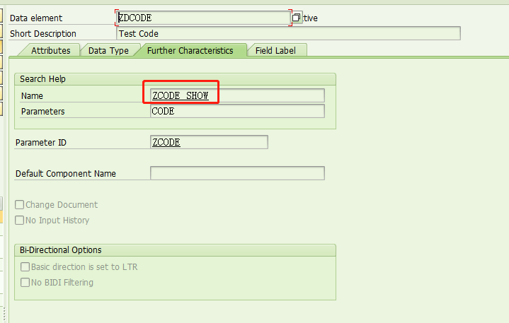

Domain:ZDCODE
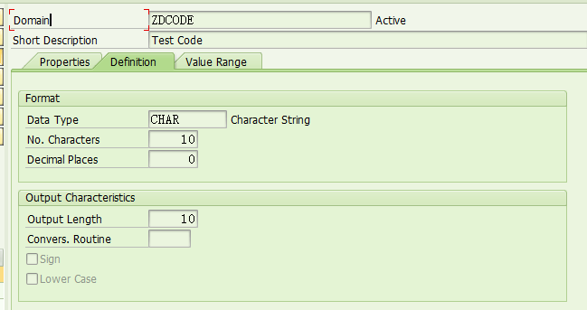
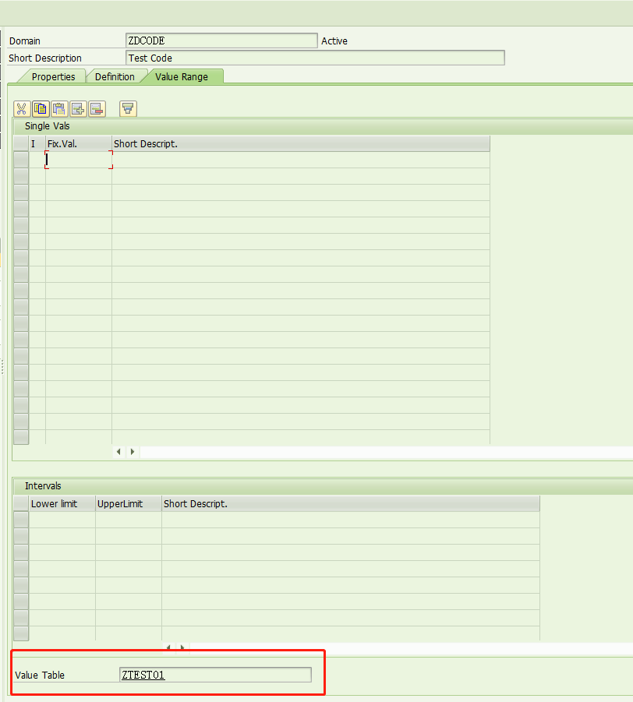

TCODE:SE11 Create Search helper(Elementary srch help) ZCODE_SHOW
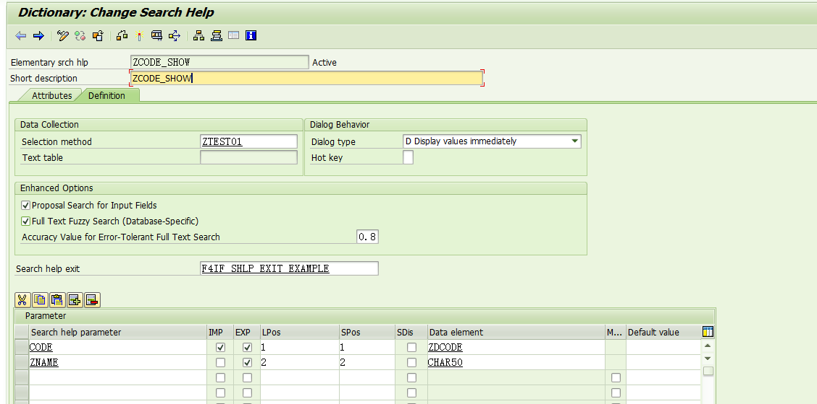

Selection method:Source table ZTEST001
Dialog type:D
Search help exit: F4IF_SHLP_EXIT_EXAMPLE
Noticeable:
IMP EXP:Return value ;
LPos SPos: show Fields Position;
SDs:Only display on Search bar
Default Value: Default Value ,it must use string format ‘’ and can use ‘**’ for vague search.

Source Code:
REPORT ZRPTEST001.
*线型池引用
TYPE-POOLS SLIS.
***********************************************************
*TABLES :声明报表中使用到的数据表
***********************************************************
TABLES:ZTEST01,ZTEST02.
***********************************************************
*SELECTION-SCREEN :定义选择屏幕中的选择字段
***********************************************************
SELECTION-SCREEN BEGIN OF BLOCK TXT01 WITH FRAME TITLE TEXT-001.
SELECT-OPTIONS: S_ZCODE FOR ZTEST02-ZCODE.
SELECTION-SCREEN END OF BLOCK TXT01.

